LAB EXPERIMENT RECORD

Department | AIDS
Course Code / Course Name | DSA0601 / Data Handling and Visualization
Experiment | Data Visualization using R
Name | B. Pallavi
Register Number | 192424243
Date | 17 October 2026
Day | Saturday

SET 24: PRODUCT INVENTORY MANAGEMENT
AIM
To analyze product inventory quantities, compare product stocks, and visualize inventory data using R.
DATASET
Product ID | Product Name | Quantity Available
1 | Product A | 250
2 | Product B | 175
3 | Product C | 300
4 | Product D | 200
5 | Product E | 220
PROGRAM 1: PRODUCT QUANTITY BAR CHART
Code:
product <- c("A","B","C","D","E")
quantity <- c(250,175,300,200,220)
barplot(quantity,
names.arg=product,
col="skyblue",
main="Product Inventory",
xlab="Product",
ylab="Quantity")

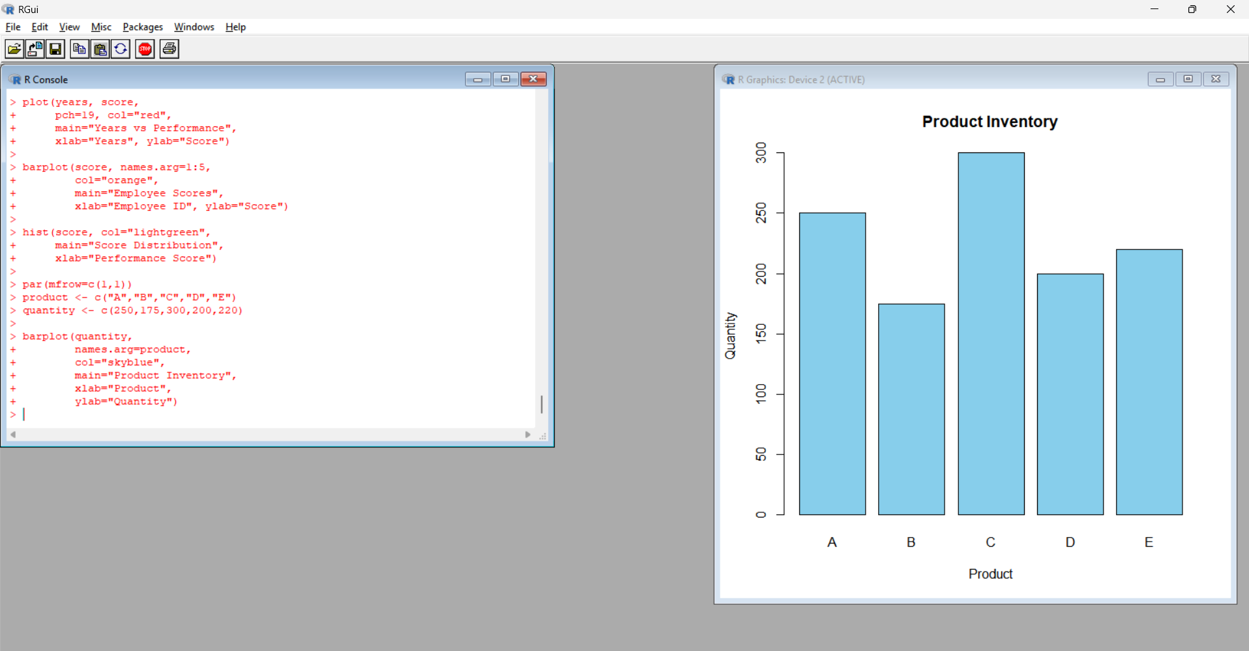
Output: A bar chart displaying the available quantity of each product.
Observation: Product C has the highest quantity of 300, while Product B has the lowest quantity of 175.
PROGRAM 2: STACKED BAR CHART
Code:
q <- matrix(c(
150,100,75,100,180,
120,110,90,120,100
), nrow=5)
rownames(q) <- c("A","B","C","D","E")
colnames(q) <- c("Category 1","Category 2")
barplot(t(q),
col=c("orange","lightgreen"),
main="Product Quantity by Category",
xlab="Product",
ylab="Quantity",
legend.text=TRUE)
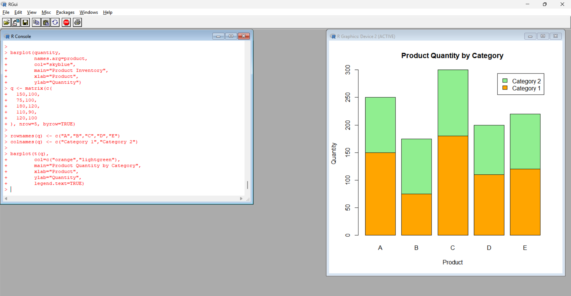
Output: A stacked bar chart comparing two categories for each product.
Observation: The chart compares illustrative category quantities. Actual category-wise data are required for accurate inventory analysis.
PROGRAM 3: PRODUCT INVENTORY TABLE
Code:
inventory <- data.frame(
Product=c("A","B","C","D","E"),
Quantity=c(250,175,300,200,220)
)
print(inventory)
print(mean(inventory$Quantity))
print(max(inventory$Quantity))
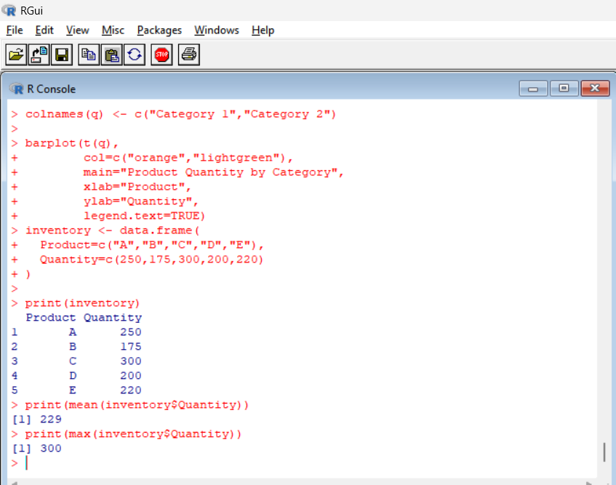
Output:
- Average inventory quantity: 229
- Maximum inventory quantity: 300
Observation: The average inventory quantity is 229 units, and Product C has the maximum stock.
PROGRAM 4: PRODUCT INVENTORY DASHBOARD
Code:
product <- c("A","B","C","D","E")
quantity <- c(250,175,300,200,220)
price <- c(20,15,18,17,19)
par(mfrow=c(2,2))
barplot(quantity, names.arg=product,
col="skyblue",
main="Product Inventory",
ylab="Quantity")
pie(quantity, labels=product,
col=rainbow(5),
main="Inventory Distribution")
plot(price, quantity,
pch=19, col="red",
main="Price vs Quantity",
xlab="Price", ylab="Quantity")
barplot(quantity, names.arg=product,
col="orange",
main="Quantity Comparison",
ylab="Quantity")
par(mfrow=c(1,1))
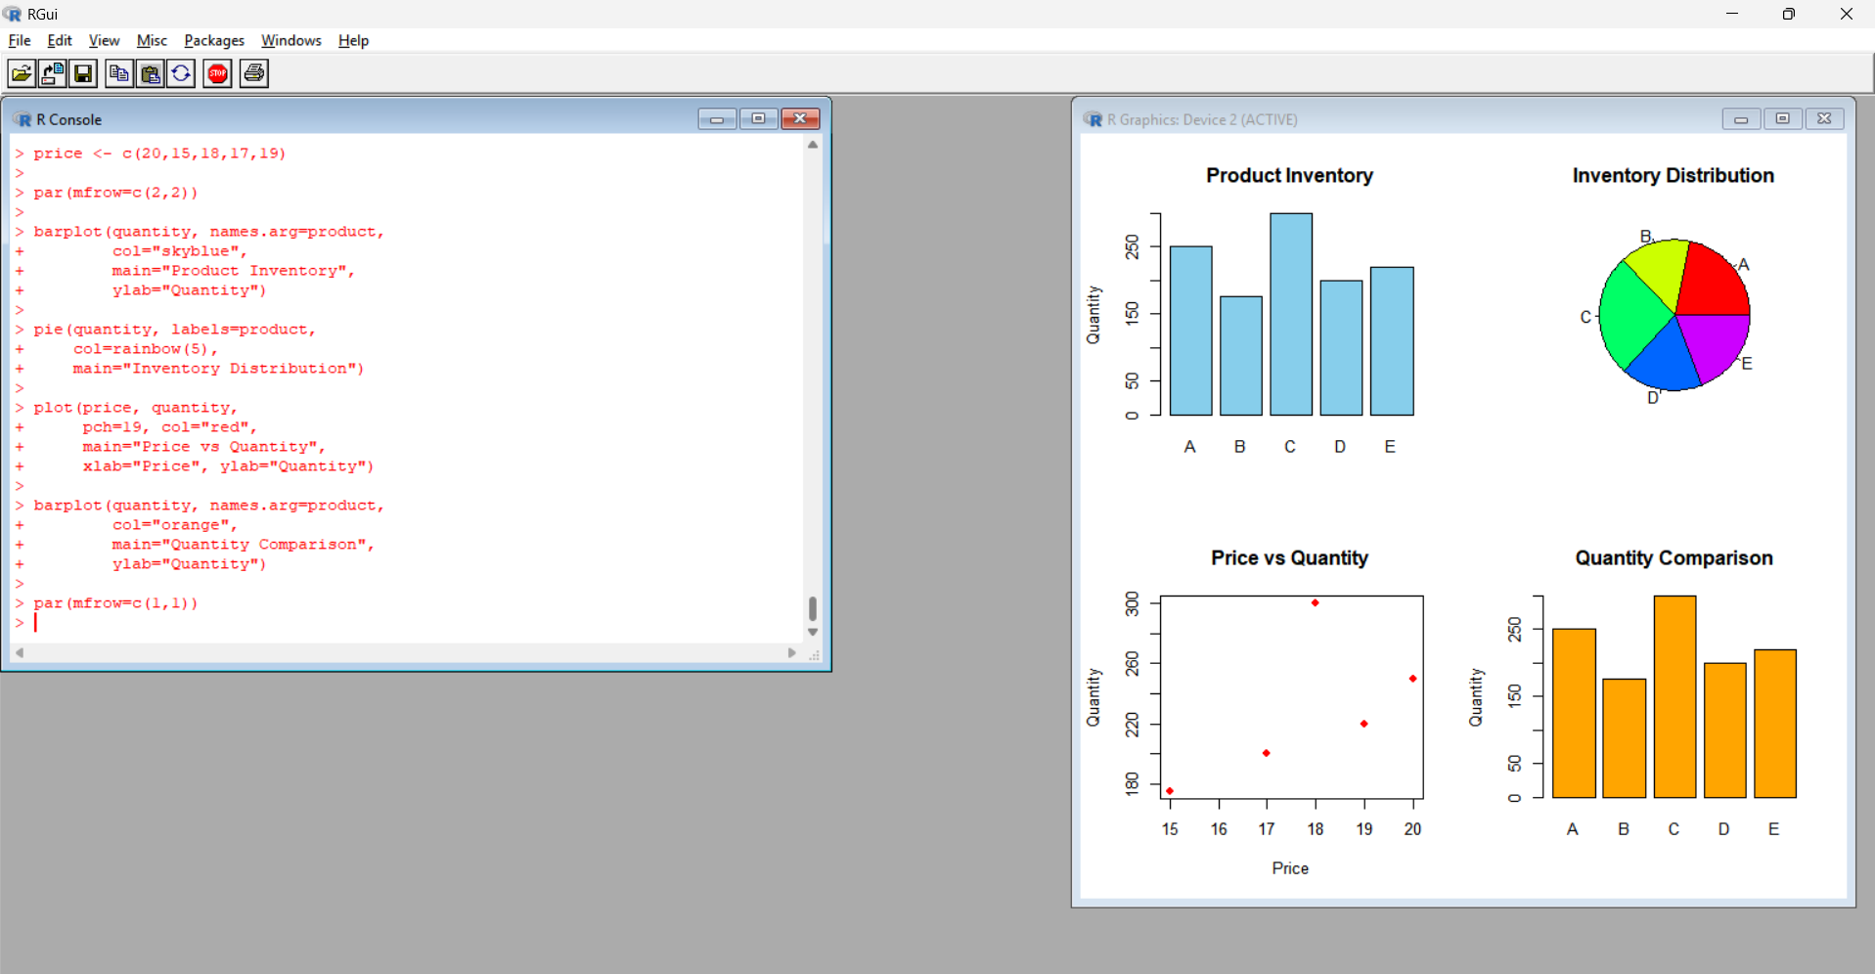
Output: A four-panel dashboard displaying inventory quantities, inventory distribution, price versus quantity, and quantity comparison.
Observation: The dashboard summarizes inventory levels. The prices used in the scatter plot are illustrative because actual prices were not provided.
RESULT
Product inventory data were analyzed using bar charts, stacked bar charts, a pie chart, a scatter plot, and summary statistics in R.

